**INPUT OUTPUT SCENARIO**

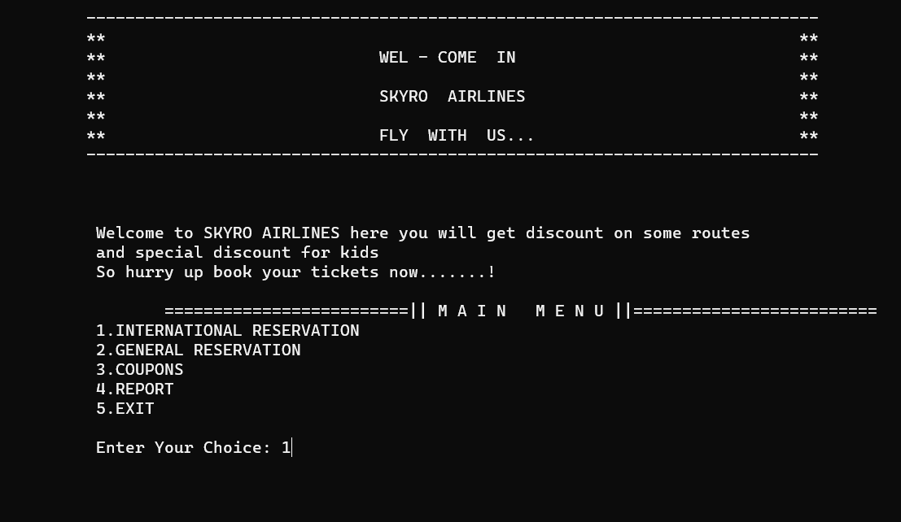

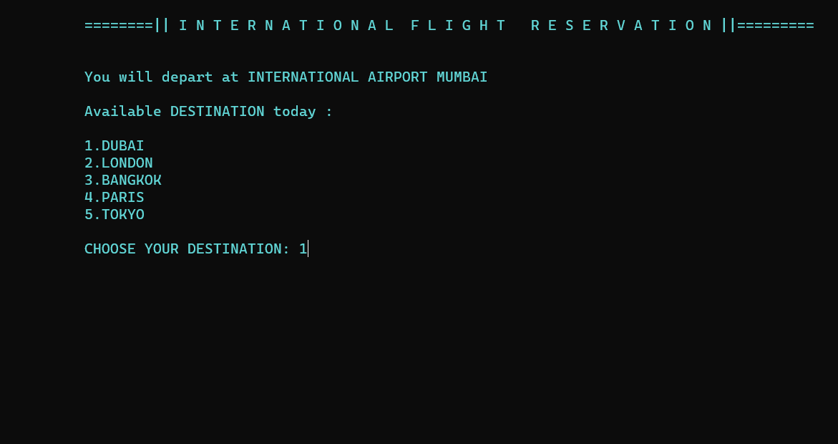

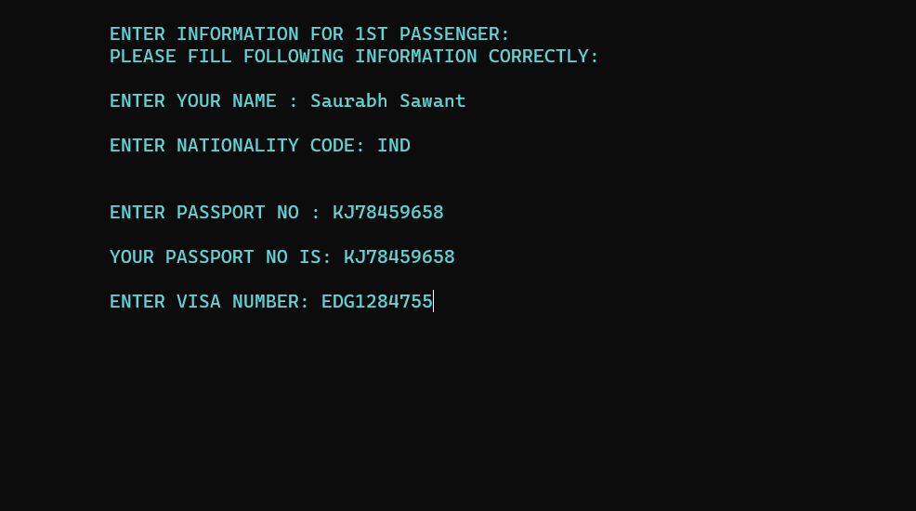

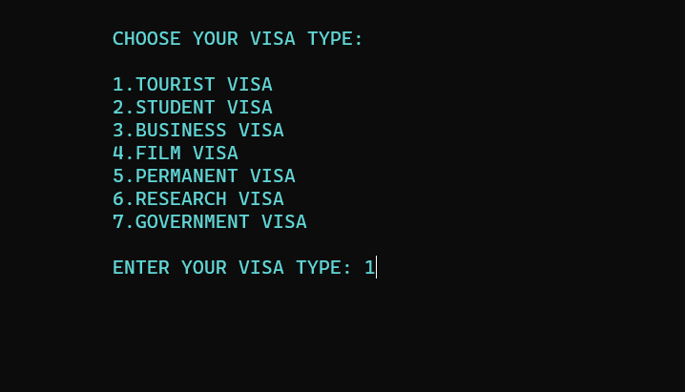

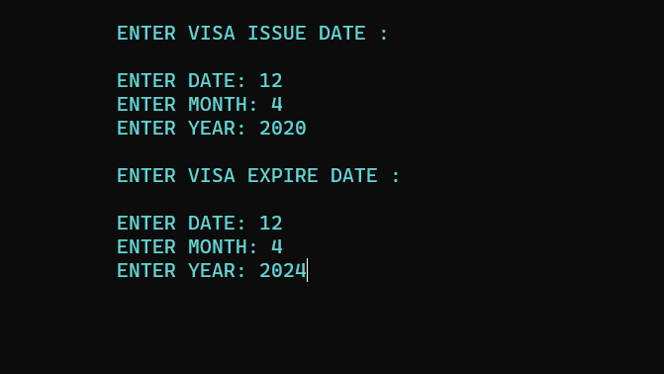

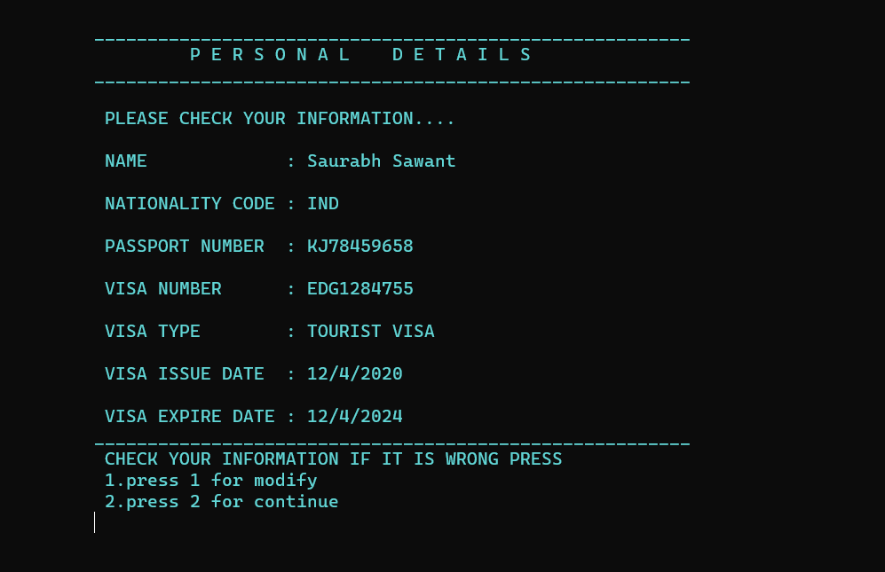

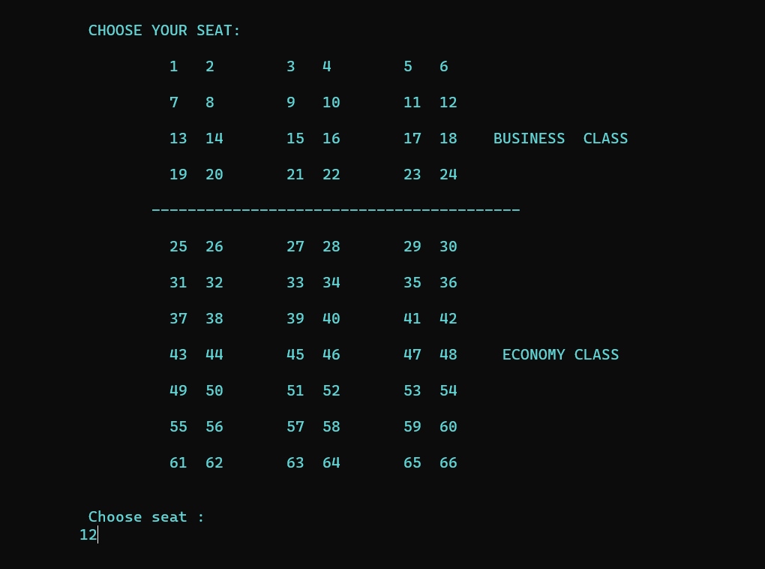

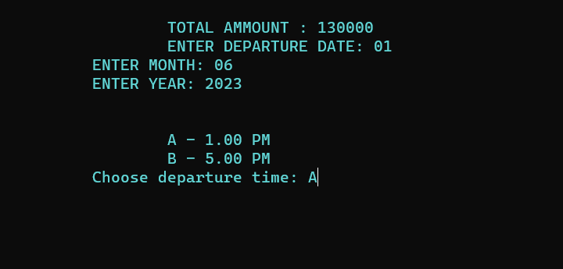

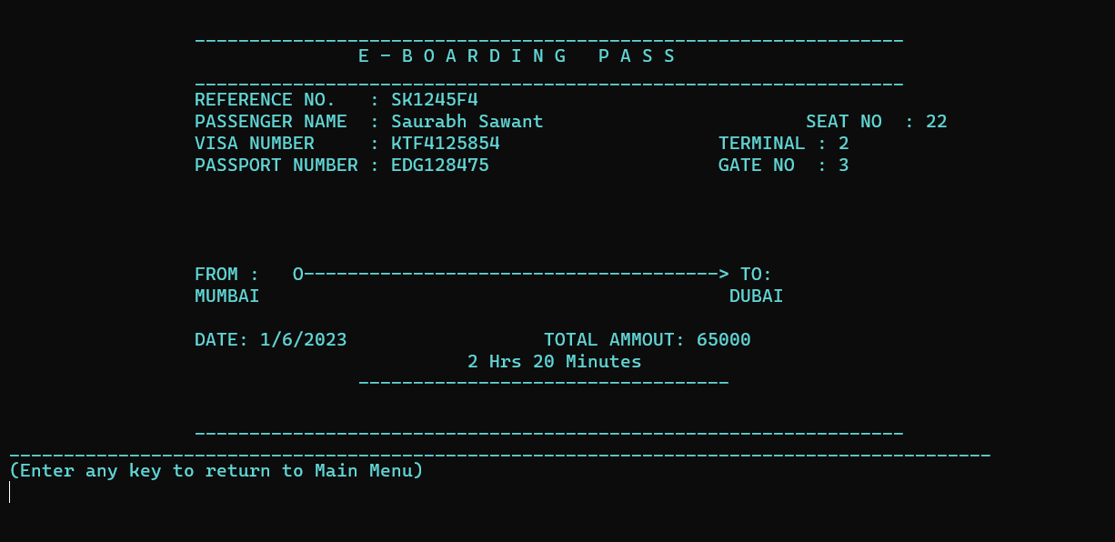

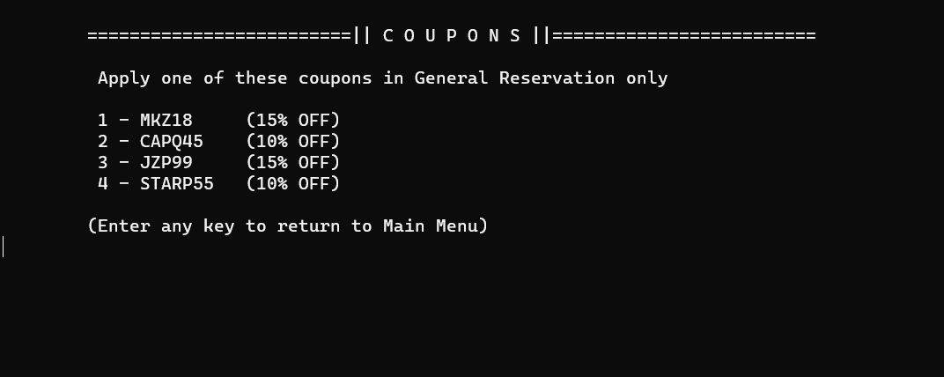

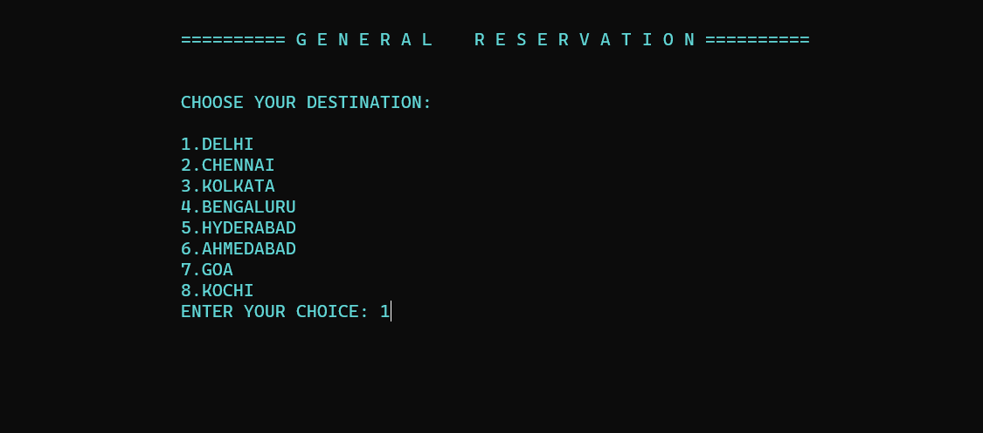

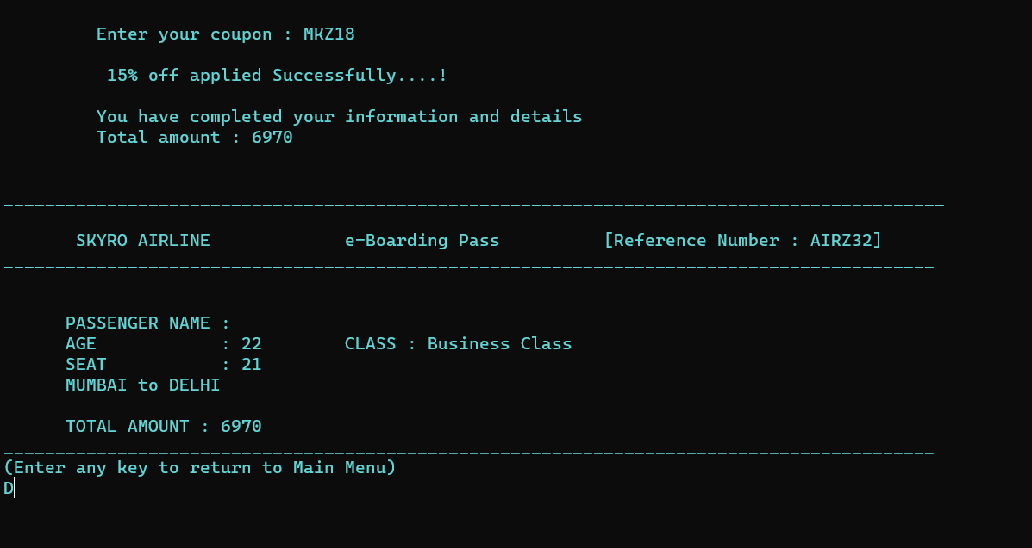

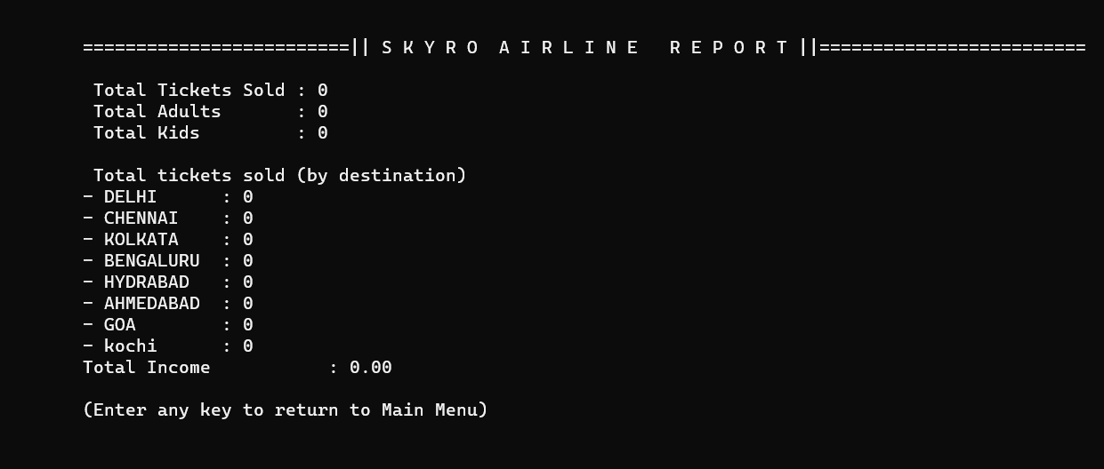

**IMPLEMENTATION**

Here we’ve displayed the menu options such as make a **international reservation,general reservation, coupons, report, and exit**.

* If the passenger wants to make a international reservation for a flight then he must choose option 1.
* If the passenger wants to make a general reservation for a flight then he must choose option 2.
* By choosing option 3 the passenger can check discount coupons .
* By choosing option 4 the user will get report which contains total tickets sold by destination ,total tickets sold to adults and kids.
* the last menu option 6 is to exit the complete project.

Now we’ll see each and every option in detail.

**International Reservation:**

By choosing menu option number 1 passengers will be able to make a international reservation for any particular flight. During the reservation software will ask for some basic details which are as follows:

Name of a passenger.

Nationality of passenger.

Seat number which you want to book.

Passport No.

Visa No.

Visa type.

Departure Time.

Boarding pass.

**International Reservation:**

By choosing menu option number 2 passengers will be able to make a international reservation for any particular flight. During the reservation software will ask for some basic details which are as follows:

Name of a passenger.

Age of passenger.

Seat number which you want to book.

Discount Coupons.

Departure Time.

Boarding pass.

**Coupons:**

By choosing menu option number 3 passengers will be able to see the discount coupon codes such as :

1. MKZ18
2. CAPQ45
3. JZP99
4. STARP55

**Report:**

By choosing menu option number 4 passengers will be able to see the reports which contain following information :

* Total tickets sold.
* Total ticket sold to adults.
* Total ticket sold to kids.
* Total ticket sold by destination
* Total income

**Exit:**

By choosing menu option number passengers will exit the complete project.